**Name : Yumna Mubeen**

**F.Name : Muhammad Nadeem**

**Section : A**

**Seat no. : B21110006165**

**Field : BSCS (4th Sem)**

**Course : Mathematics IV (Numerical Computing) (406)**

**Teacher : Ma’am DR Noor Fatima Siddiqui (NFS)**

**Trapezoidal , Simpson’s 1/3rd , Simpson’s 3/8 Rules:**

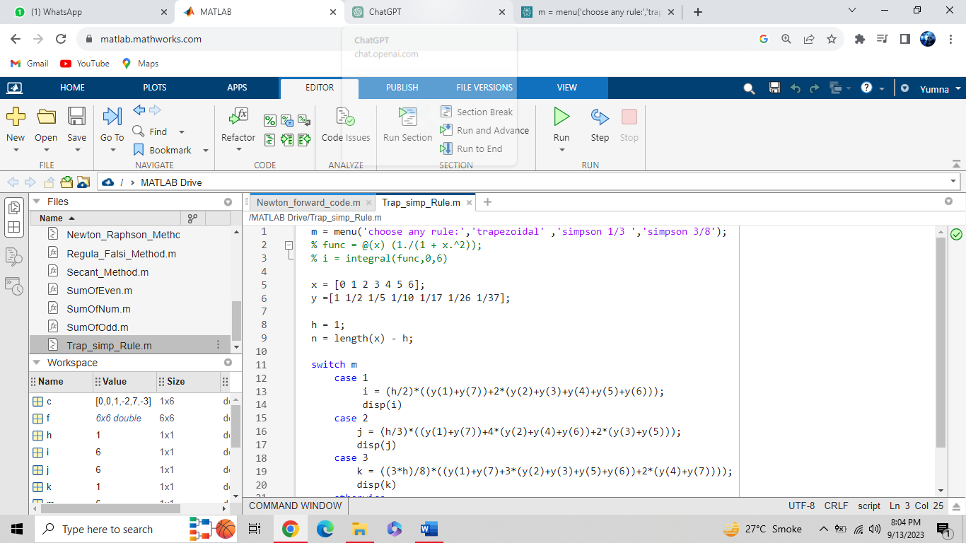

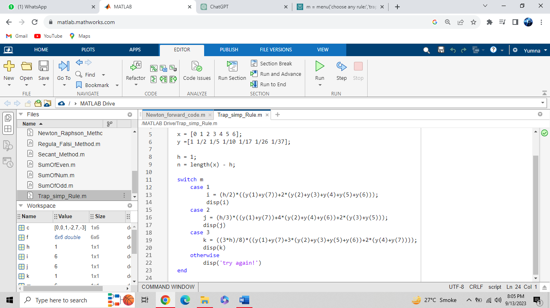

**Output :**

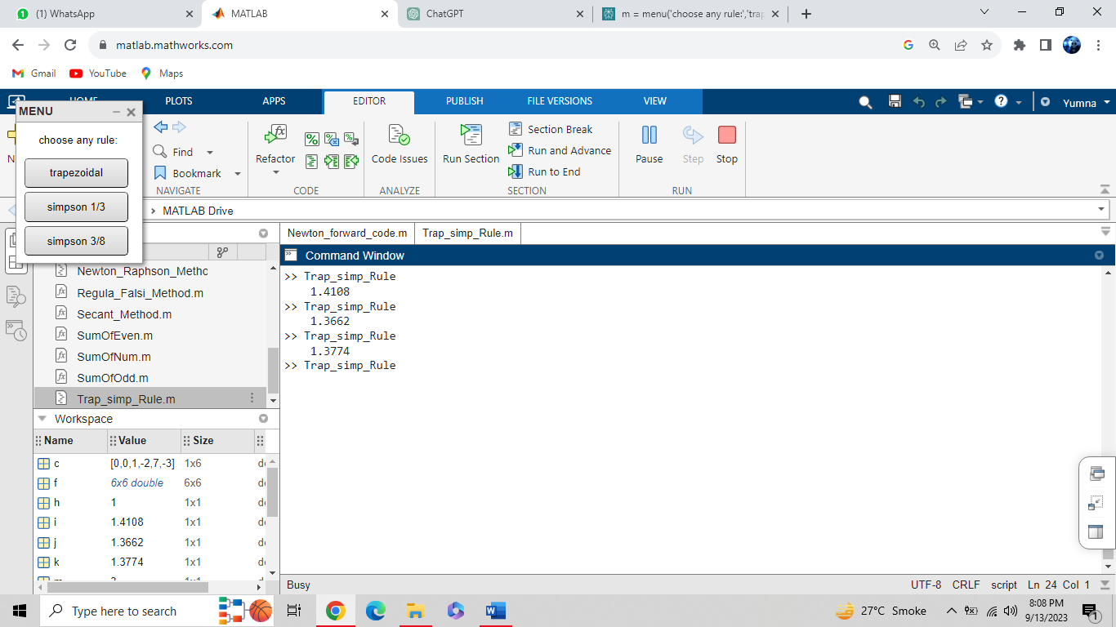

**Newton Forward Difference Interpolation :**

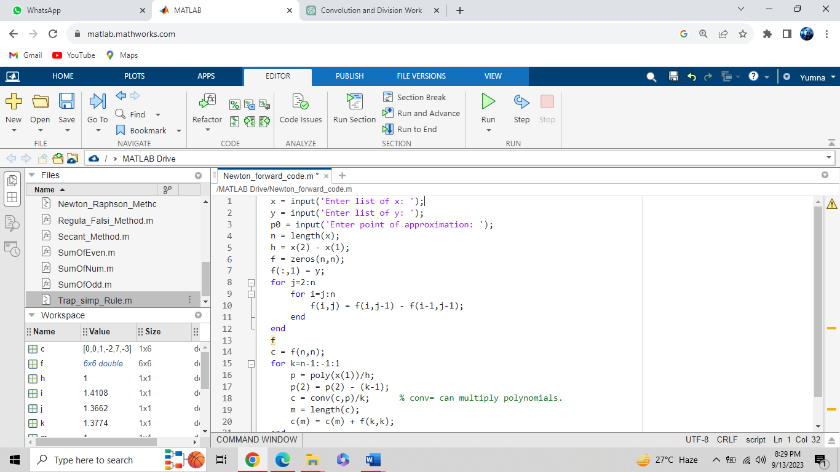

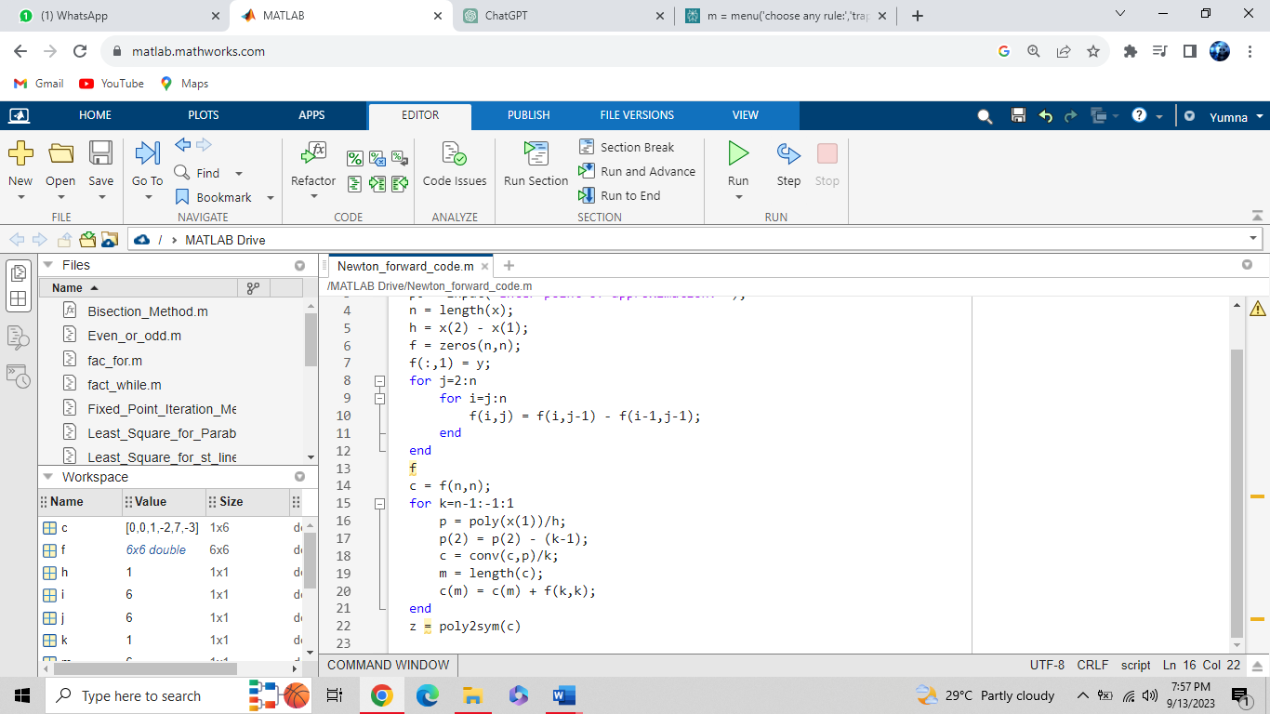

**Output :**

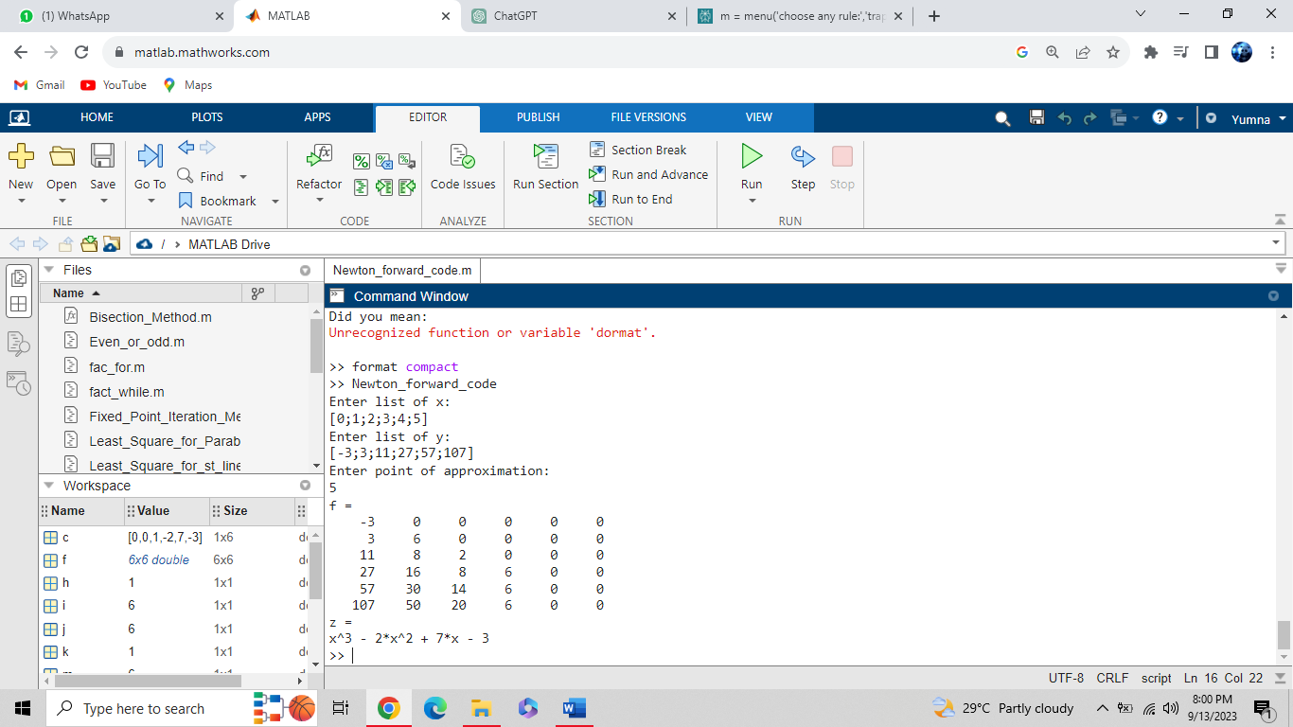

**Newton Backward Difference Interpolation :**

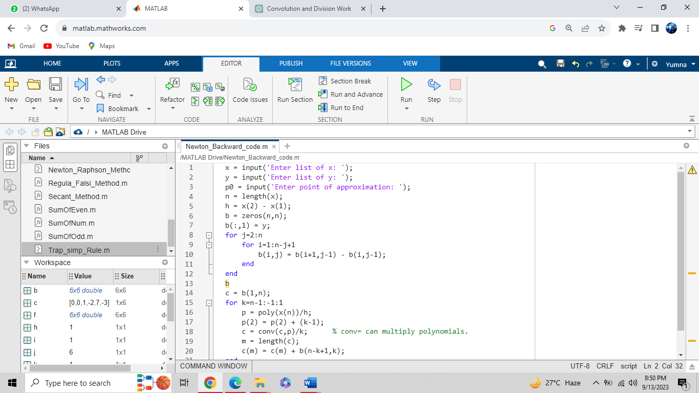

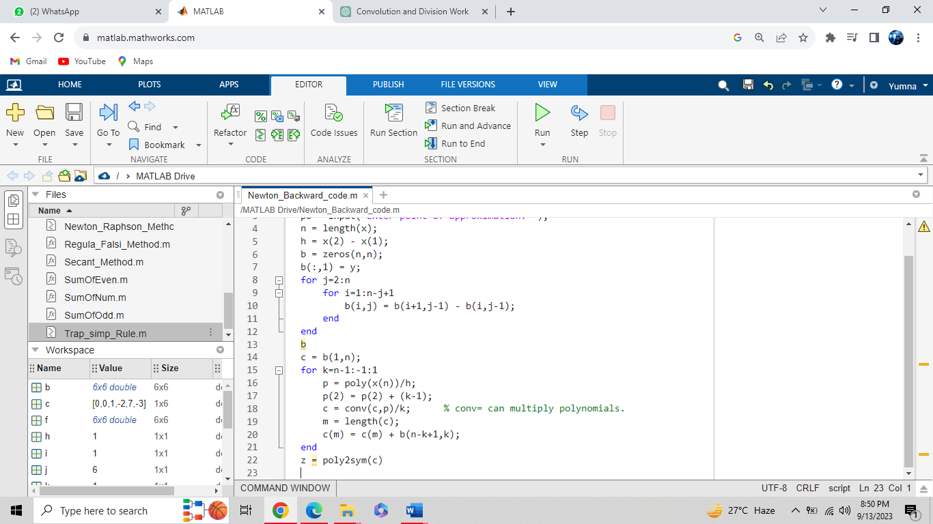

**Output :**

